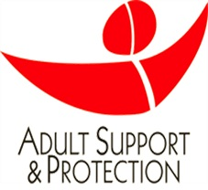
TRAINING FOR THOSE WORKING IN THE HIGHLAND COUNCIL AREA ONLY.
STAFF WORKING IN ARGYLL AND BUTE, SHOULD REFER TO THAT COUNCIL’S WEBSITE.

Highland Adult Protection Training Booking Form
(Please Complete all sections)
Your Details
NAME:
YOUR EMAIL THAT IS RECORDED ON TURAS (Must be registered on TURAS )
JOB ROLE:
EMPLOYER DETAILS:

LOCALITY:
DIRECT LINE MANAGER:
DIRECT LINE MANAGER CONTACT DETAILS (email and contact number)

Please see TURAS for available dates for training and insert below your preferred date(s).
(It would be advisable to give more than one suitable date as courses can book up quickly)
Course Level:
Course Dates Requested

- Please note we require, when practically possible, to be made aware that you are unable to attend the training course; failure to let us know will result in us contacting your line manager, unfortunately this is due to the high number of no shows at training.
- Adult Protection Training is mandatory training for various job roles and spaces are limited therefore we require to have all spaces filled to ensure we are meeting the demand – no shows impact our ability to reallocate the space to others.
- Confirmation of your booking will come via TURAS.
- Please send all booking form requests to nhshighland.asptraining@nhs.scot as an attachment to an email.

